**Hotel Reservation System**

* **Introduction-**

Hotel Reservation System will help hotel staff (admin) as well as customer to reserve the room according to room type, number of guests, duration of stay and availability of the room online. They will also be able to look the facilities and features provided for the selected room. It will also help staff to manage and keep hotel related records like customer details and billing details, extra charges for paid services. Customer & Staff can login with unique ID and register which can be used to retrieve, change or cancel booking.

* **Need for Hotel Reservation System-**

Following are the reason for which Hotel Reservation System is required-

1. Manual booking system are tedious and confusing, people have to book by calling hotel staff.
2. This method does not give customer information how hotel looks, what feature their room will have etc.
3. Customers cannot make changes as per their requirements.
4. For staff, it is difficult to maintain records as well as check in checkout time for each and everyone.
5. Further customer cannot give feedback online so, management cannot work on that feedback to make services better.

* **A well-formed use case diagram, identifying your actors and major use cases and setting the context-**

Following is UML diagram for Hotel Reservation Systems. It gives a graphic overview of the actors and the roles they play in a system. It also shows how different functions that can be performed by the actors and how they interact.

Main actors for the Hotel Reservation Systems are-

1. Customers
2. Receptionist
3. Manager

Lucid Chart link for Used-Case Diagram for Hotel Reservation System-

<https://www.lucidchart.com/invitations/accept/b5ae0065-b9d5-4c9a-ae9b-ee4ccb2a40b4>

**Used -Case Diagram-**

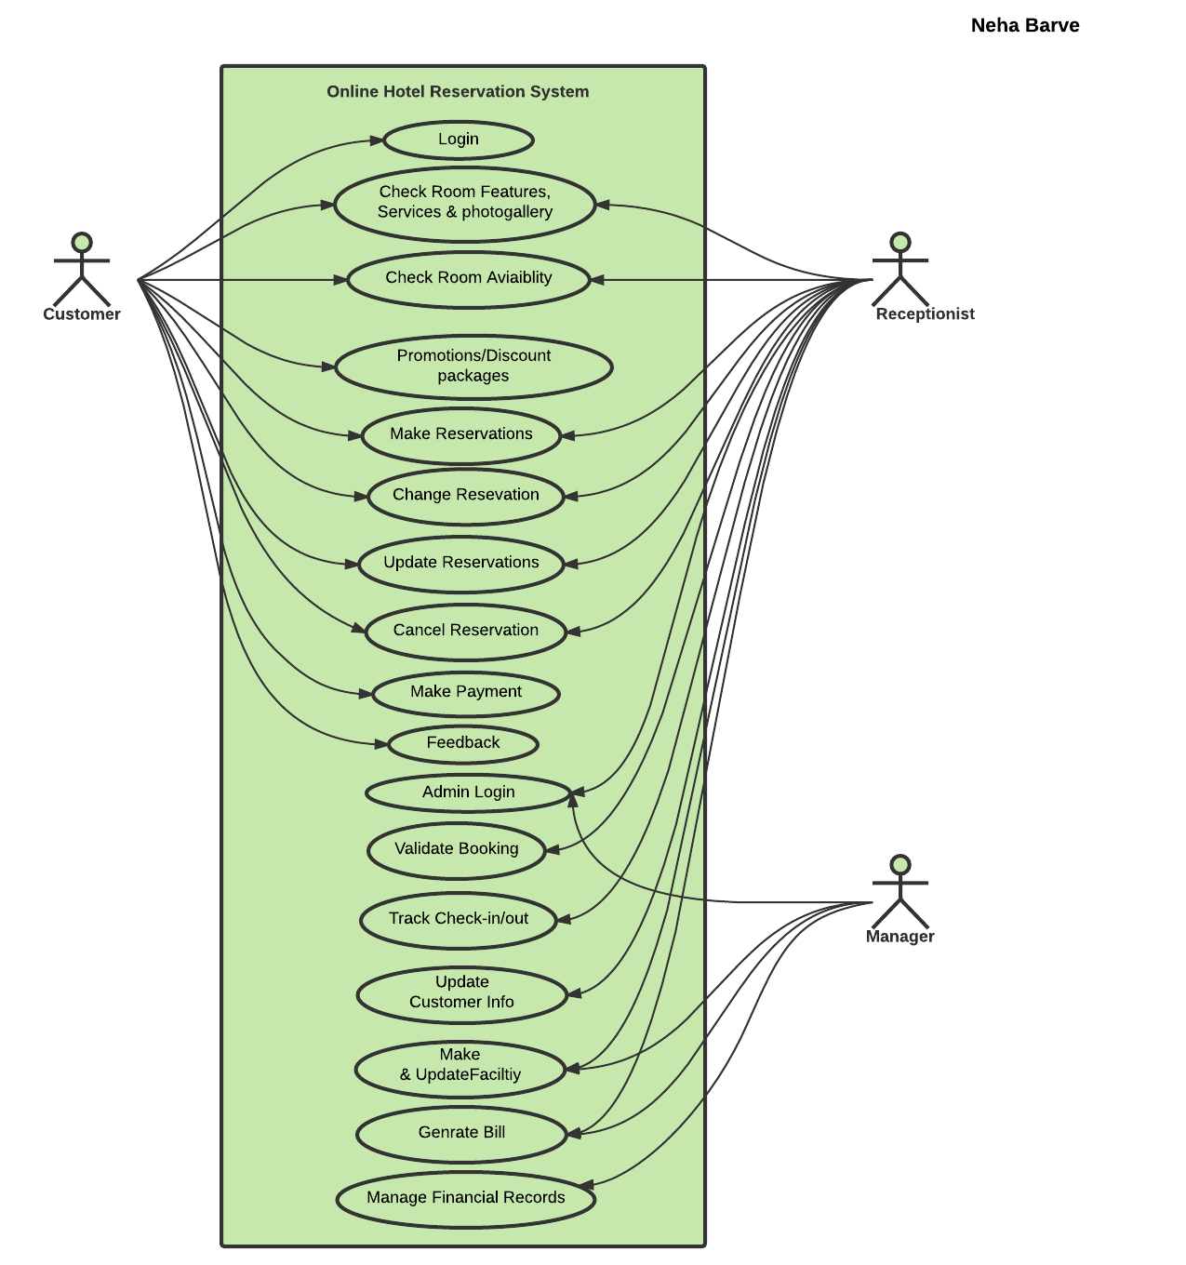

* **One well-documented use case description with main and alternate flows identified**

1. **Used Case-Login**

|  |  |
| --- | --- |
| **Name** | Login |
| **Actor** | Customer |
| **Description** | Enter login id and password |
| **Successful Output** | Customer can retrieve old bookings and manage his account. |
| **Alternative** | Customer is not registered member |
| **Precondition** | Customer should be registered to login |

1. **User Case- Check Room Availability**

|  |  |
| --- | --- |
| **Name** | Check Room Availability |
| **Actor** | Customer, Receptionist |
| **Description** | Customer & Receptionist can check weather the required type of room is available or not. |
| **Successful Output** | If available they can make booking. |
| **Alternative** | If room not available there can be option to add on waiting list. |
| **Precondition** | None |

1. **Used Case- Check Room Features, Services and Photo gallery**

|  |  |
| --- | --- |
| **Name** | Check Room Features, Services and Photo gallery |
| **Actor** | Customer, Receptionist |
| **Description** | Can check features and services provided in room and can select accordingly. |
| **Successful Output** | Can select room type as per need and rates |
| **Alternative** | None |
| **Precondition** | None |

1. **Used Case-Promotion/Discount Packages**

|  |  |
| --- | --- |
| **Name** | Promotion/Discount Packages |
| **Actor** | Customer, Receptionist |
| **Description** | Can enjoy discounted rates and packages |
| **Successful Output** | Have to pay less than actual rates |
| **Alternative** | None |
| **Precondition** | Requires coupon, promotional code or gift card. |

1. **Used Case-Make reservation**

|  |  |
| --- | --- |
| **Name** | Make reservation |
| **Actor** | Customer, Receptionist |
| **Description** | If required room type is available than reservation can be made |
| **Successful Output** | Make reservation |
| **Alternative** | None |
| **Precondition** | Customer or admin needs to login |
| **Postcondition** | Database can be updated |

1. **Used Case-Change or Update Reservations**

|  |  |
| --- | --- |
| **Name** | Change or Update reservation |
| **Actor** | Customer, Receptionist |
| **Description** | Changes or update can be made after reservation. |
| **Successful Output** | Required update or changes made |
| **Alternative** | None |
| **Precondition** | Customer or admin needs to login and there should be reservation. |
| **Postconditions** | Other rooms availability will be available.  Database can be updated by staff. |

1. **Used Case-Cancel Reservations**

|  |  |
| --- | --- |
| **Name** | Cancel reservation |
| **Actor** | Customer, Receptionist |
| **Description** | Cancellation can be done after reservation is done. |
| **Successful Output** | Booking will be cancelled. |
| **Alternative** | Options if again new booking are to be made. |
| **Precondition** | Customer or admin needs to login and there should be reservation. |
| **Postcondition** | No booking will be there for customers.  Database will be updated. |

1. **Used Case-Make Payment**

|  |  |
| --- | --- |
| **Name** | Payment |
| **Actor** | Customer |
| **Description** | Payment methods |
| **Successful Output** | Customer will receive an invoice  Staff can enter payment details. |
| **Alternative** | Customer can pay after reaching hotel |
| **Precondition** | Customer needs to login |
| **Postcondition** | Booking will be confirmed. |

1. **Used Case-Feedback**

|  |  |
| --- | --- |
| **Name** | Feedback |
| **Actor** | Customer |
| **Description** | Questions related to services and customer experience. |
| **Successful Output** | Suggested possible changes can be according to feedback to make quality of services better. |
| **Alternative** | None |
| **Precondition** | Customer needs to login |

1. **Used Case-Admin Login**

|  |  |
| --- | --- |
| **Name** | Admin Login |
| **Actor** | Receptionist, Manager |
| **Description** | Enter login id and password |
| **Successful Output** | Both can manage bookings and another management job. |
| **Alternative** | Admin is not registered member |
| **Precondition** | Admin should be registered to login |

1. **Used Case-Validate Booking**

|  |  |
| --- | --- |
| **Name** | Validate Booking |
| **Actor** | Receptionist |
| **Description** | Not more than 2 adults in one room. |
| **Successful Output** | Valid bookings are confirmed. |
| **Alternative** | Invalid Bookings |
| **Precondition** | Admin should login to validate. |

1. **Used Case-Track Check-In/Check-Out**

|  |  |
| --- | --- |
| **Name** | Track Check-In/Check-Out |
| **Actor** | Receptionist |
| **Description** | Customers should leave hotel as per their check-out time else they will be charged. |
| **Successful Output** | Check-in, Check-out time can be tracked |
| **Alternative** | If customers stay more than check-out time. |
| **Precondition** | None |

1. **Used Case-Update Customer Information**

|  |  |
| --- | --- |
| **Name** | Update Customer Information |
| **Actor** | Receptionist |
| **Description** | Database system is updated with customer information. |
| **Successful Output** | Customer information is feed into system |
| **Alternative** | None |
| **Precondition** | Customer should have room reservation. |

1. **Used Case-Make and Update Facility**

|  |  |
| --- | --- |
| **Name** | Make and Update Facility |
| **Actor** | Receptionist |
| **Description** | Customer is provided with required facility such as cleaning, breakfast |
| **Successful Output** | Provided with required facility. |
| **Alternative** | None |
| **Precondition** | Customer should have room reservation. |

1. **Used Case-Generate Bill**

|  |  |
| --- | --- |
| **Name** | Generate Bill |
| **Actor** | Receptionist |
| **Description** | Generate bill according to facilities used and number of days of stay. |
| **Successful Output** | Booking details and generate bill |
| **Alternative** | None |
| **Precondition** | Customer should have room reservation. |

1. **Used Case-Manage Financial Records**

|  |  |
| --- | --- |
| **Name** | Manage Financial Records |
| **Actor** | Manager |
| **Description** | Reports can be made according to business. |
| **Successful Output** | Report generation and profit reports |
| **Alternative** | None |
| **Precondition** | None |

* **Basic Activity Diagram for Hotel Reservation System-**

**Link for Activity Diagram –**

<https://www.lucidchart.com/invitations/accept/6f5e2ad9-a9d7-4427-8b75-425386655897>

Following is Activity Diagram for Hotel Reservation Systems-

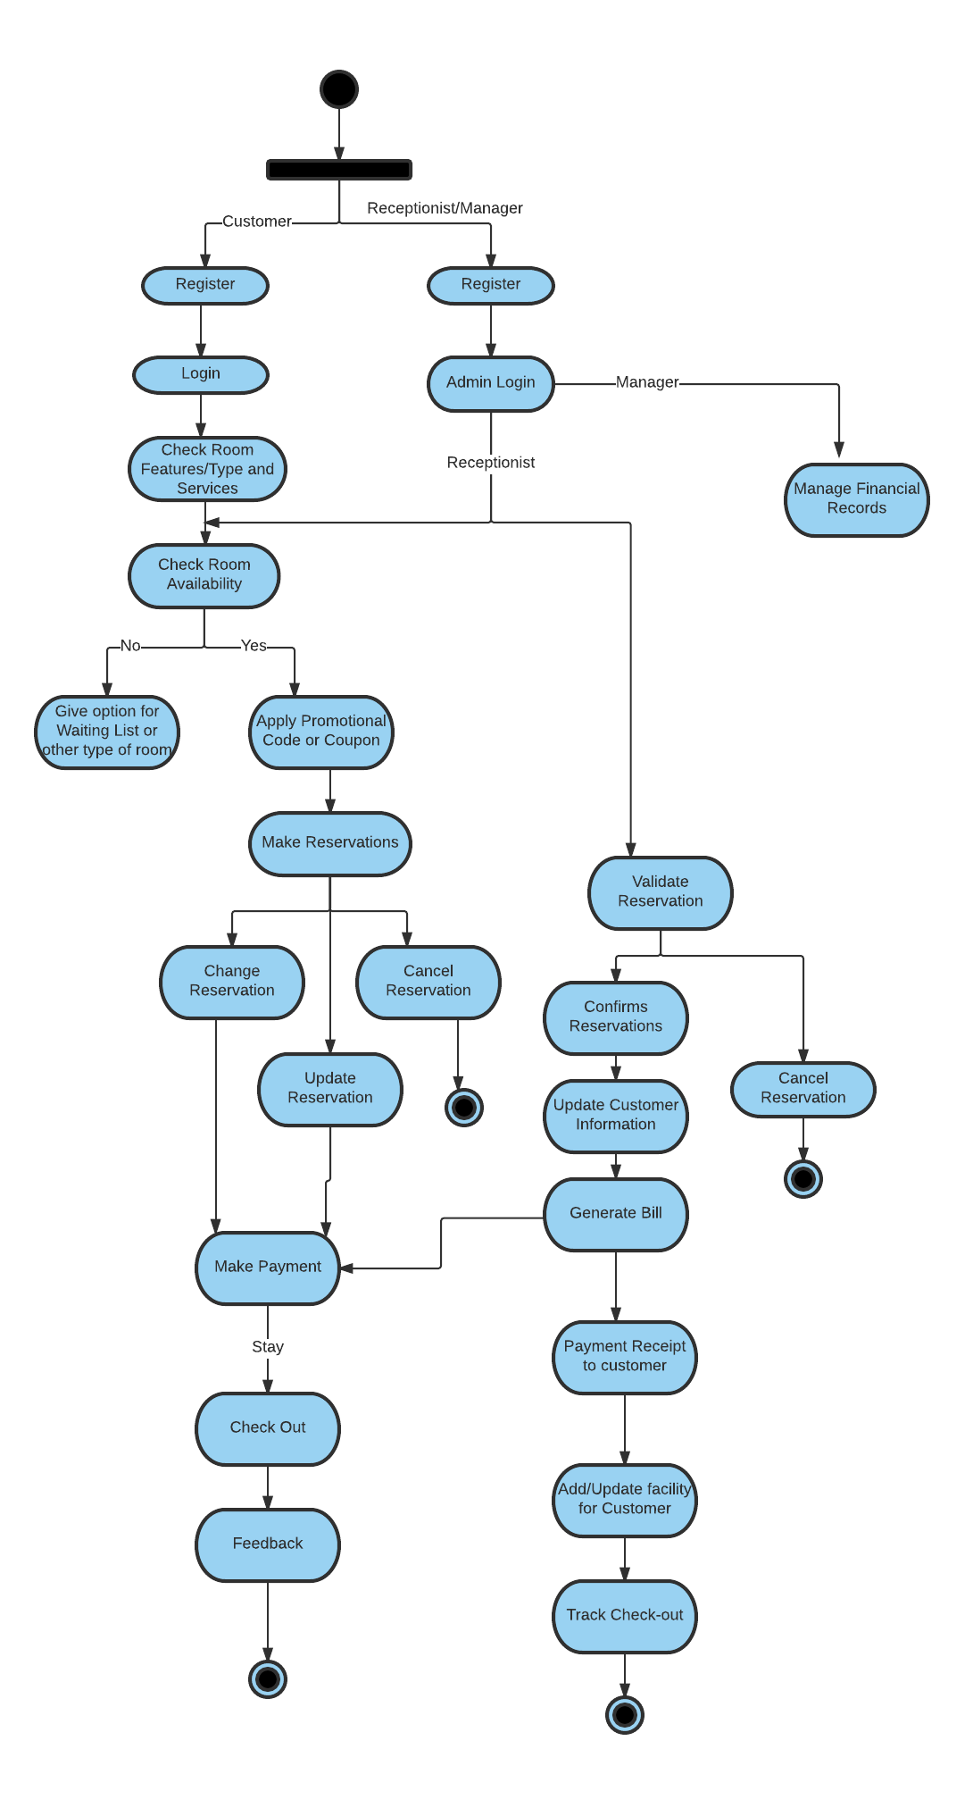

* **A high-level project plans**

Following is the project plan for reaming project-

1. **UML Design-**

-To prepare class diagram for Hotel Reservation System with multiplicity

-Sequence Diagram related to Class Diagram

1. **Physical Design-**

-Work on physical design for the system

1. **Test Plan-**

-To work on Test Plans and their outcomes

1. **Implementation Requirements-**

-Software/Hardware Requirements

1. **Limitations**